DEPARTMENT OF INDUSTRIAL RELATIONS DIVISION OF OCCUPATIONAL SAFETY AND HEALTH

California Code of Regulations

Title 8, Division 1, Chapter 7, Subchapter 1, Article 2, Sections 14300.35 and 14300.41.
Text of Amended Regulations
Language proposed to be added is underlined; Language proposed to be deleted is in strikethrough;

§ 14300.35. Employee Involvement.
- Basic requirement. Your employees and their representatives must be involved in the recordkeeping system in several ways.
  - You must inform each employee of how he or she is to report an a work-related injury or illness to you.
  - You must provide limited access to your injury and illness records for your employees and their representatives. as described in paragraph (b)(2) of this section.
- Implementation.
  - What must I do to make sure that employees report work-related injuries and illnesses to me?
    - You must set up a way for employees to report work-related injuries and illnesses promptly; and
    - You must tell each employee how to report work-related injuries and illnesses to you.
  - Do I have to give my employees and their representatives access to the injury and illness records required by this article?
Yes. Your employees, former employees, their personal representatives, and their authorized employee representatives have the right to access the injury and illness records required by this article, with some limitations, as discussed below.
    - Who is an authorized employee representative?
An authorized employee representative is an authorized collective bargaining agent of employees.
    - Who is a personal representative of an employee or former employee?

A personal representative is:

      - Any person that the employee or former employee designates as such, in writing; or
      - The legal representative of a deceased or legally incapacitated employee or former employee.
    - If an employee or his or her representative asks for access to the Cal/OSHA Form 300 and annual summary when do I have to provide it?
When an employee, former employee, personal representative, or authorized employee representative asks for copies of your current or stored Cal/OSHA 300 forms or a current or stored annual summary for an establishment the employee or former employee has worked in, you must give the requester a copy of the relevant Cal/OSHA 300 forms and annual summaries by the end of the next business day.
Exception: If your establishment is in NAICS SIC Code 781 5121, you must give the requester the information within 7 seven (7) calendar days.
    - May I remove the names of the employees or any other information from the Cal/OSHA Form 300 before I give copies to an employee, former employee, or employee representative?
No. You must leave the names on the Cal/OSHA Form 300. However, to protect the privacy of injured and ill employees, you may not record the employee's name on the Cal/OSHA Form 300 for certain “privacy concern cases” as specified in Sections 14300.29(b)(6) through 14300.29(b)(9).
    - If an employee or representative asks for access to the Cal/OSHA 301 Incident Report, when do I have to provide it?
      - When an employee, former employee, or personal representative asks for a copy of the Cal/OSHA Form 301 Incident Report describing an injury or illness to that employee or former employee, you must give the requester a copy of the Cal/OSHA 301 Incident Report containing that information by the end of the next business day.
Exception: If your establishment is in NAICS SIC Code 781 5121, you must give the requester the information within 7 seven (7) calendar days.
      - When an authorized employee representative asks for copies of the Cal/OSHA 301 Incident Reports or equivalent forms for an establishment where the agent represents employees under a collective bargaining agreement, you must give copies of those forms to the

authorized employee representative within seven (7) calendar days but with the following personally identifying information deleted:
        - Name;
        - Address;
        - Date of birth;
        - Date of hire;
        - Gender;
        - Name of physician;
        - Location where treatment was provided;
        - Whether the employee was treated in an emergency room; and
        - Whether the employee was hospitalized overnight as an in- patient.
    - May I charge for the copies?
No. You may not charge for these copies the first time they are provided. However, if one of the designated persons asks for additional copies, you may assess a reasonable charge for retrieving and copying the records.
- With the exception of provisions to protect the privacy of employees in subsections (b)(2)(D) and (b)(2)(E) of this section and in subsections (b)(6) through (b)(10) in Section 14300.29, nothing in this section shall be deemed to preclude employees and employee representatives from collectively bargaining to obtain access to information relating to occupational injuries and illnesses in addition to the information made available under this section.
Note: Authority cited: Sections 150(b) and 6410, Labor Code. Reference: Section 6410, Labor Code.

§ 14300.41. Annual OSHA Injury and Illness Survey. Electronic Submission of Injury and Illness Records to OSHA.
- Basic requirement. If you receive OSHA's annual survey form, you must fill it out and send it to OSHA or OSHA's designee, as stated on the survey form. You must report the following information for the year described on the form:
  - the number of workers you employed; Annual electronic submission of Cal/OSHA injury and illness records by establishments with 250 or more employees. If your establishment had 250 or more employees at any time during the previous calendar year, and this article requires your establishment to keep records, then you must electronically submit information from the Cal/OSHA Form 300A Summary of Work-Related Injuries and Illnesses that you keep under this part to OSHA or OSHA’s designee. You must submit the information once a year, no later than the date listed in paragraph (c) of this section of the year after the calendar year covered by the forms.
  - the number of hours worked by your employees; and Annual electronic submission of Cal/OSHA Form 300A Summary of Work-Related Injuries and Illnesses by establishments with 20 or more employees but fewer than 250 employees in designated industries. If your establishment had 20 or more employees but fewer than 250 employees at any time during the previous calendar year, and your establishment is classified in an industry listed in Appendix H for Title 8 Sections 14300 – 14300.48, then you must electronically submit information from Cal/OSHA Form 300A Summary of Work-Related Injuries and Illnesses to OSHA or OSHA’s designee. You must submit the information once a year, no later than the date listed in paragraph (c) of this section of the year after the calendar year covered by the form.
  - the requested information from the records that you keep under the provisions of this article. Electronic submission of records upon notification. Upon notification, you must electronically submit the requested information from your Cal/OSHA injury and illness records to OSHA or OSHA’s designee.
  - Electronic submission of the Employer Identification Number (EIN). For each establishment that is subject to these reporting requirements, you must provide the EIN used by the establishment.
- Implementation.
  - Does every employer have to send data to routinely submit information from the Cal/OSHA injury and illness records to OSHA or its designee?
No., only two categories of employers must routinely submit information from their Cal/OSHA injury and illness records. Each year, OSHA or its designee sends injury and illness survey forms to employers in certain industries. In any year, some employers will receive an OSHA survey form and others will not. You do not have to send injury and illness data to OSHA or its designee unless you receive a survey form. First, if your establishment had 250 or more employees at any time during the previous calendar year, and this article requires your establishment to keep records, then you must submit the required Cal/OSHA Form 300A information to OSHA once

a year. Second, if your establishment had 20 or more employees but fewer than 250 employees at any time during the previous calendar year, and your establishment is classified in an industry listed in Appendix H for Title 8 Sections 14300 – 14300.48, then you must submit the required Cal/OSHA Form 300A information to OSHA once a year. Employers in these two categories must submit the required information by the date listed in paragraph (c) of this section of the year after the calendar year covered by the form or forms (for example, 2018 for the 2017 forms). If you are not in either of these two categories, then you must submit information from the injury and illness records to OSHA only if OSHA notifies you to do so for an individual data collection.
  - How quickly do I need to respond to an OSHA survey form? If I have to submit information under paragraph (a)(1) of this section, do I have to submit all of the information from the recordkeeping form?
You must send the survey reports to OSHA or its designee by mail or other means described in the survey form, within 30 calendar days, or by the date stated in the survey form, whichever is later.
Yes, you are required to submit all of the information from the Form 300A.
  - Do I have to respond to an OSHA survey form if I am normally exempt from keeping OSHA injury and illness records? Do part-time, seasonal, or temporary workers count as employees in the criteria for number of employees in paragraph (a) of this section?
Yes. Even if you are exempt from keeping injury and illness records under Section 14300.1 to Section 14300.3, OSHA or its designee may inform you in writing that it will be collecting injury and illness information from you in the following year. If you receive such a letter, you must keep the injury and illness records required by this article and make a survey report for the year covered by the survey.
Yes, each individual employed in the establishment at any time during the calendar year counts as one employee, including full-time, part-time, seasonal, and temporary workers.
  - Do I have to answer the OSHA survey form if I am located in a State-Plan State? How will OSHA notify me that I must submit information from the injury and illness records as part of an individual data collection under paragraph (a)(3) of this section?
OSHA will notify you by mail if you will have to submit information as part of an individual data collection under paragraph (a)(3). OSHA will also announce individual data collections through publication in the Federal Register and the OSHA newsletter, and announcements on the OSHA Web site. If you are an employer who

must routinely submit the information, then OSHA will not notify you about your routine submittal.
Yes. All employers who receive survey forms must respond to the survey, even those in State-Plan States.
  - Does this section affect the Division of Occupational Safety and Health's authority to inspect my workplace?
No. Nothing in this section affects the Division of Occupational Safety and Health's statutory authority to investigate conditions related to occupational safety and health.
  - How often do I have to submit the information from the injury and illness records?
If you are required to submit information under paragraph (a)(1) or (2) of this section, then you must submit the information once a year, by the date listed in paragraph (c) of this section of the year after the calendar year covered by the form or forms. If you are submitting information because OSHA notified you to submit information as part of an individual data collection under paragraph (a)(3) of this section, then you must submit the information as often as specified in the notification.
  - How do I submit the information?
You must submit the information electronically. OSHA will provide a secure Web site for the electronic submission of information. For individual data collections under paragraph (a)(3) of this section, OSHA will include the Web site’s location in the notification for the data collection.
  - Do I have to submit information if my establishment is partially exempt from keeping Cal/OSHA injury and illness records?
If you are partially exempt from keeping injury and illness records under §§ 14300.1 and/or 14300.2, then you do not have to routinely submit Article 2 information under paragraphs (a)(1) and (2) of this section. You will have to submit information under paragraph (a)(3) of this section if OSHA informs you in writing that it will collect injury and illness information from you. If you receive such a notification, then you must keep the Cal/OSHA injury and illness records required by Article 2 and submit information as directed.
  - Do I have to submit information if I am located in a State Plan State? Yes, the requirements apply to employers located in State Plan States.
  - May an enterprise or corporate office electronically submit Cal/OSHA injury and illness records for its establishment(s)?

Yes, if your enterprise or corporate office had ownership of or control over one or more establishments required to submit information under paragraph (a)(1) or (2) of this section, then the enterprise or corporate office may collect and electronically submit the information for the establishment(s).
- Reporting dates.
  - In 2018, establishments required to submit under paragraph (a)(1) or (2) of this section must submit the required information for 2017 according to the table in this paragraph (c)(1):

Submission year | Establishments submitting under paragraph (a)(1) of this section must submit the required information from this form/these forms: | Establishments submitting under paragraph (a)(2) of this section must submit the required information from this form: | Submission deadline
2018 | 300A | 300A | December 31, 2018
  - Beginning in 2019, establishments that are required to submit under paragraph (a)(1) or (2) of this section will have to submit all of the required information by March 2 of the year after the calendar year covered by the form or forms (for example, by March 2, 2019, for the forms covering 2018).
Note: Authority cited: Sections 150(b) and 6410, Labor Code. Reference: Section 6410, Labor Code.

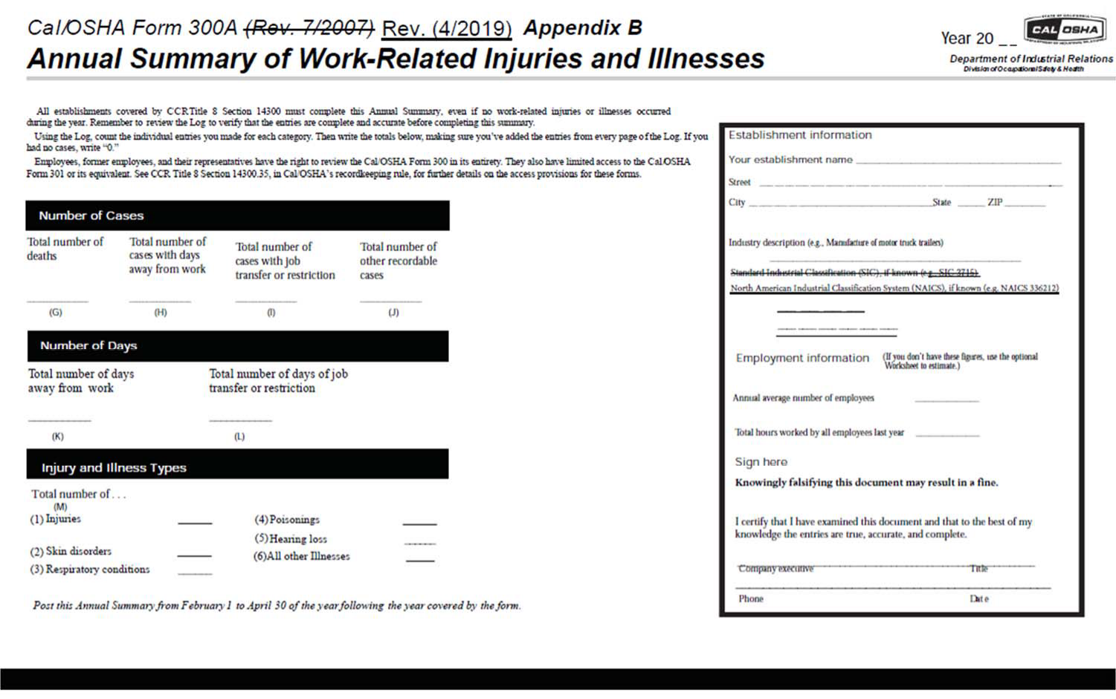

{00081970.DOCX} 8

Appendix E - Required Elements for the Cal/OSHA Form 300A, Annual Summary of Work-Related Injuries and Illnesses Equivalent Form
A. Employers who are required to complete the Cal/OSHA Form 300A may use an equivalent form that provides all of the following information:
- The number of cases:
    - The total number of deaths
    - The total number of cases with days away from work
    - The total number of cases with job transfers or restriction
    - The total number of other recordable cases
- The number of days:
    - The total number of days of job transfer or restriction
    - The total number of days away from work
    - Injury and Illness Types, the total numbers of:
      - Injuries
      - Skin disorders
      - Respiratory conditions
      - Poisonings
      - All other illnesses
- Posting requirement statement: "Post this Annual Summary from February 1 to April 30 of the year following the year covered by the form."
- Establishment information:
The establishment name Street address
City, State, Zip Industry description

The North American Industrial Classification System Standard Industry Classification Code, if known.
- Employment information
The annual average number of employees.
The total hours worked by all employees last year.
(For assistance in calculating the annual average number of employees, and total hours worked, refer to Appendix G.)

- Sign Here:
Admonition: "Knowingly falsifying this statement may result in a fine."
Certification statement: "I certify that I have examined this document and that to the best of my knowledge the entries are true, accurate, and complete."
Space for the signature of the company executive, and title. Phone number of signatory.
Date of the certification.

NOTE: Authority cited: Sections 150(b) and 6410, Labor Code. Reference: Section 6410, Labor Code.

Appendix H

Designated Industries for § 14300.41(a)(2) Annual Electronic Submission of Cal/OSHA Form 300A Summary of Work-Related Injuries and Illnesses by Establishments With 20 or More Employees but Fewer Than 250 Employees in Designated Industries

NAICS | Industry
11 | Agriculture, forestry, fishing and hunting.
22 | Utilities.
23 | Construction.
31-33 | Manufacturing.
42 | Wholesale trade.
4413 | Automotive parts, accessories, and tire stores.
4421 | Furniture stores.
4422 | Home furnishings stores.
4441 | Building material and supplies dealers.
4442 | Lawn and garden equipment and supplies stores.
4451 | Grocery stores.
4452 | Specialty food stores.
4521 | Department stores.
4529 | Other general merchandise stores.
4533 | Used merchandise stores.
4542 | Vending machine operators.
4543 | Direct selling establishments.
4811 | Scheduled air transportation.
4841 | General freight trucking.
4842 | Specialized freight trucking.
4851 | Urban transit systems.
4852 | Interurban and rural bus transportation.
4853 | Taxi and limousine service.
4854 | School and employee bus transportation.
4855 | Charter bus industry.
4859 | Other transit and ground passenger transportation.
4871 | Scenic and sightseeing transportation, land.
4881 | Support activities for air transportation.
4882 | Support activities for rail transportation.
4883 | Support activities for water transportation.
4884 | Support activities for road transportation.
4889 | Other support activities for transportation.
4911 | Postal service.
4921 | Couriers and express delivery services.
4922 | Local messengers and local delivery.
4931 | Warehousing and storage.
5152 | Cable and other subscription programming.
5311 | Lessors of real estate.
5321 | Automotive equipment rental and leasing.
5322 | Consumer goods rental.
5323 | General rental centers.
5617 | Services to buildings and dwellings.
5621 | Waste collection.
5622 | Waste treatment and disposal.
5629 | Remediation and other waste management services.
6219 | Other ambulatory health care services.
6221 | General medical and surgical hospitals.
6222 | Psychiatric and substance abuse hospitals.
6223 | Specialty (except psychiatric and substance abuse) hospitals.
6231 | Nursing care facilities.
6232 | Residential mental retardation, mental health and substance abuse facilities.
6233 | Community care facilities for the elderly.
6239 | Other residential care facilities.
6242 | Community food and housing, and emergency and other relief services.
6243 | Vocational rehabilitation services.
7111 | Performing arts companies.
7112 | Spectator sports.
7121 | Museums, historical sites, and similar institutions.
7131 | Amusement parks and arcades.
7132 | Gambling industries.
7211 | Traveler accommodation.
7212 | RV (recreational vehicle) parks and recreational camps.
7213 | Rooming and boarding houses.
7223 | Special food services.
8113 | Commercial and industrial machinery and equipment (except automotive and electronic) repair and maintenance.
8123 | Dry-cleaning and laundry services.
Note: Authority cited: Section 6410, Labor Code. Reference: Section 6410, Labor Code.

